**Unit 2: Wireless LANS , Mobile IP, WAP and WEB Services [25%]**

**2.1** ● **Wireless LANS:** Wireless LAN and Communication using Infrared, Radio Frequency.

A **wireless LAN** (**WLAN**) is a [wireless computer network](https://en.wikipedia.org/wiki/Wireless_network) that links two or more devices using [wireless communication](https://en.wikipedia.org/wiki/Wireless_communication) to form a [local area network](https://en.wikipedia.org/wiki/Local_area_network) (LAN) within a limited area such as a home, school, computer laboratory, campus, or office building. This gives users the ability to move around within the area and remain connected to the network. Through a [gateway](https://en.wikipedia.org/wiki/Gateway_(telecommunications)), a WLAN can also provide a connection to the wider [Internet](https://en.wikipedia.org/wiki/Internet).

Most modern WLANs are based on [IEEE 802.11](https://en.wikipedia.org/wiki/IEEE_802.11) standards and are marketed under the [Wi-Fi](https://en.wikipedia.org/wiki/Wi-Fi) brand name.

**Advantages of WLANs**

* They provide clutter-free homes, offices and other networked places.
* The LANs are scalable in nature, i.e. devices may be added or removed from the network at greater ease than wired LANs.
* The system is portable within the network coverage. Access to the network is not bounded by the length of the cables.
* Installation and setup are much easier than wired counterparts.
* The equipment and setup costs are reduced.

**Disadvantages of WLANs**

* Since radio waves are used for communications, the signals are noisier with more interference from nearby systems.
* Greater care is needed for encrypting information. Also, they are more prone to errors. So, they require greater bandwidth than the wired LANs.
* WLANs are slower than wired LANs.

**WLAN Communication using Infrared:**

WLAN Infrared Communication refers to the process of sending data and communicating wirelessly on top of an infrared connection. It is the use of infrared transmission technology in devices and equipments for sending data to other devices and/or controlling them wirelessly by human operators

Infrared wireless is primarily implemented in short range areas and facilities, more specifically where there is the least amount of obstruction such as wooden or concrete walls.

The first mode is called line of sight infrared wireless. This is the most common implementation of infrared wireless. The receiving device must be directly in line of sight of the infrared broadcasting device. The distance between both devices usually must not be greater than ten meters. Remote devices such as televisions, air-conditioners and other appliances works on line of sight infrared wireless technology.

The second mode is called scatter mode infrared wireless. In this mode, the infrared signals/rays are broadcasted within a specific room or vicinity. Any receiving device either in sight or out of sight can receive infrared signals directly or through reflection.

**Video about WLAN Communication using IR ( 3.54 Minutes)**

<https://www.youtube.com/watch?v=HYpWGzBteQg>

**Radio Frequency :**

**Radio frequency** (RF) is a measurement representing the oscillation rate of electromagnetic radiation spectrum, or electromagnetic **radio** waves, from **frequencies** ranging from 300 GHz to as low as 9 kHz.

RF Definition Video (1.58 Minutes)

<https://www.youtube.com/watch?v=3Wp8qpDIM5Y>

Short for radio frequency, RF is any frequency within the electromagnetic spectrum associated with radio wave propagation. When an RF current is supplied to an antenna, an electromagnetic field is created that then is able to propagate through space. Many wireless technologies are based on RF field propagation.

The following frequencies make up part of the electromagnetic radiation spectrum:

* Ultra-low frequency (ULF) -- 0-3 Hz
* Extremely low frequency (ELF) -- 3 Hz - 3 kHz
* Very low frequency (VLF) -- 3kHz - 30 kHz
* Low frequency (LF) -- 30 kHz - 300 kHz
* Medium frequency (MF) -- 300 kHz - 3 MHz
* High frequency (HF) -- 3MHz - 30 MHz
* Very high frequency (VHF) -- 30 MHz - 300 MHz
* Ultra-high frequency (UHF)-- 300MHz - 3 GHz
* Super high frequency (SHF) -- 3GHz - 30 GHz
* Extremely high frequency (EHF) -- 30GHz - 300 GHz

**2.2 Mobile IP:** Introduction, Entities, Agents, Address Types.

Mobile IP :

**Mobile IP** (or **MIP**) is an [Internet Engineering Task Force](https://en.wikipedia.org/wiki/Internet_Engineering_Task_Force) (IETF) standard communications [protocol](https://en.wikipedia.org/wiki/Protocol_(computing)) that is designed to allow mobile device users to move from one network to another while maintaining a permanent IP address.

How to know IP Address of your phone…? (1.2 Mins)

<https://www.youtube.com/watch?v=D9Ana2mhOww>

How to find IP Address during connected to WiFi (1.5 Mins)

<https://www.youtube.com/watch?v=UB1Q-6XesCI>

An **Internet Protocol address** (**IP address**) is a numerical label assigned to each device (e.g., computer, printer) participating in a computer network that uses the Internet Protocol for communication. An IP address serves two principal functions: host or network interface identification and location addressing. Its role has been characterized as follows: “A name indicates what we seek. An address indicates where it is. A route indicates how to get there.”

Mobile Internet Protocol (or Mobile IP)

Last Updated: 05-12-2019

Mobile IP is a communication protocol (created by extending Internet Protocol, IP) that allows the users to move from one network to another with the same IP address. It ensures that the communication will continue without user’s sessions or connections being dropped.

Terminologies:

* Mobile Node (MN):  
  It is the hand-held communication device that the user caries e.g. Cell phone.
* Home Network:  
  It is a network to which the mobile node originally belongs to as per its assigned IP address (home address).
* Home Agent (HA):  
  It is a router in home network to which the mobile node was originally connected
* Home Address:  
  It is the permanent IP address assigned to the mobile node (within its home network).
* Foreign Network:  
  It is the current network to which the mobile node is visiting (away from its home network).
* Foreign Agent (FA):  
  It is a router in foreign network to which mobile node is currently connected. The packets from the home agent are sent to the foreign agent which delivers it to the mobile node.
* Correspondent Node (CN):  
  It is a device on the internet communicating to the mobile node.
* Care of Address (COA):  
  It is the temporary address used by a mobile node while it is moving away from its home network.

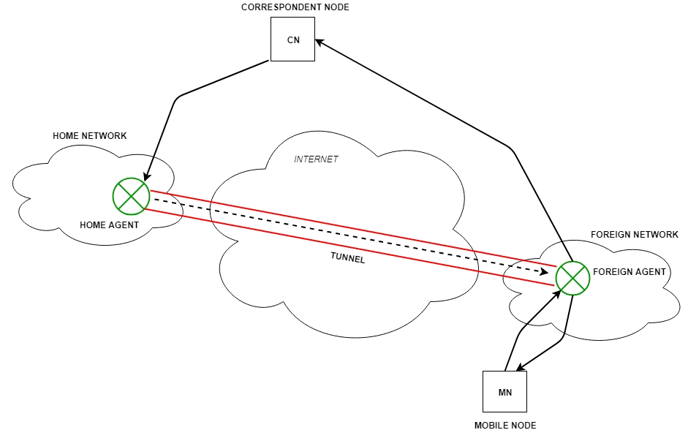

**Bholabhai Patel College Of Computer Studies, Gandhinagar**

**(A constituent College of Kadi Sarva Vishwavidyalaya)**

**BCA Programme**

**Semester - V – BCA 504: Mobile Application Development**

**Reference Material**

**Unit 2.3- WIRELESS APPLICATION PROTOCOL**

**2.3.WAP**

**2.3.1 Introduction-Concept**

**2.3.2 Need of WAP**

**2.3.3 WAP Architecture**

**2.3.4 Benefits of WAP**

**2.3.5 Examples of WAP**

**2.3.1 Introduction-Concept**

WAP is an international standard establishing how mobile devices can access information on the Internet. It is a widely used set of protocols used on wireless devices such as mobile phones and PDAs.

WAP is the worldwide standard for providing Internet communications and advanced telephony services on digital mobile phones, pagers, personal digital assistants, and other wireless terminals

WAP stands for **Wireless Application Protocol**. The dictionary definition of these terms are as follows −

* Wireless − Lacking or not requiring a wire or wires pertaining to radio transmission.
* Application − A computer program or piece of computer software that is designed to do a specific task.
* Protocol − A set of technical rules about how information should be transmitted.

WAP is the set of rules governing the transmission and reception of data by computer applications on or via wireless devices like mobile phones. WAP allows wireless devices to view specifically designed pages from the Internet using only plain text and very simple black-and-white pictures.

WAP is a standardized technology for cross-platform, distributed computing very similar to the Internet's combination of Hypertext Markup Language (HTML) and Hypertext Transfer Protocol (HTTP), except that it is optimized for:

* low-display capability
* low-memory
* low-bandwidth devices, such as personal digital assistants (PDAs), wireless phones, and pagers.

**Need of WAP / Importance of WAP**

With the appearance of WAP, we have the massive information, communication, and data resources of the Internet becoming more easily available to anyone with a mobile phone or communications device.

WAP being open and secure, is well suited for many different applications including, but not limited to stock market information, weather forecasts, enterprise data, and games.

**WAP Architecture**

**The Internet Model**

The Internet model makes it possible for a client to reach services on a large number of origin servers, each addressed by a unique Uniform Resource Locator (URL).

The content stored on the servers is of various formats

The figure below shows how a WWW client request a resource stored on a web server. On the Internet standard communication protocols, like HTTP and Transmission Control Protocol/Internet Protocol (TCP/IP) are used as displayed in **Figure 2.3.1.**

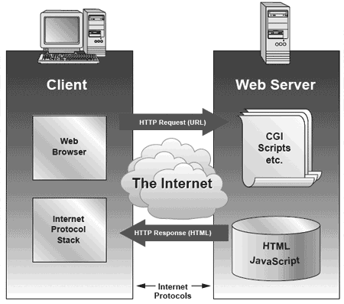

**Figure 2.3.1 : Internet Model**

**The WAP Model**

The figure below shows the WAP programming model. Note, the similarities with the Internet model. Without the WAP Gateway/Proxy, the two models would have been practically identical as displayed in **Figure 2.3.2**

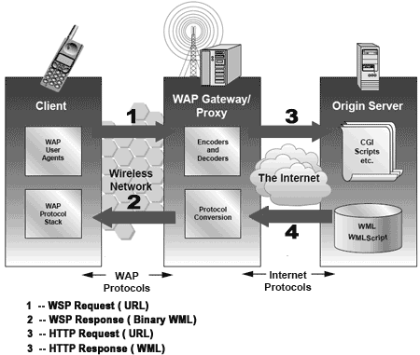

**Figure 2.3.2 : WAP Model**

WAP Gateway/Proxy is the entity that connects the wireless domain with the Internet. You should make a note that the request that is sent from the wireless client to the WAP Gateway/Proxy uses the Wireless Session Protocol (WSP). In its essence, WSP is a binary version of HTTP.

A markup language − the Wireless Markup Language (WML) has been adapted to develop optimized WAP applications. In order to save valuable bandwidth in the wireless network, WML can be encoded into a compact binary format. Encoding WML is one of the tasks performed by the WAP Gateway/Proxy.

**3.4 Benefits of WAP**

At present, all major wireless carriers support the WAP specification. This universal support is expected to continue as WAP evolves, providing a robust, intuitive way to extend Web content to wireless devices. Various groups may gain from WAP −

* + Portability.
  + Easy to use.
  + Access to a wide variety of services on a competitive market.
  + The possibility of having personalized services.
  + Fast, convenient, and efficient access to services.
  + Fulfill as many customers needs as possible, WAP devices will be available in various form factors, e.g. pagers, handheld PCs, and phones.
  + Address new market segments of mobile users by enabling a wider range of mobile VAS.
  + Attractive interface to services will increase usage.
  + Increased revenues per user due to higher network utilization.
  + Address a new customer base in the wireless community.
* **WAP supports legacy WAP 1.x protocols** that encode and optimize content for low-bandwidth, high-latency networks
* **WAP supports wireless profiles of Internet protocols** for interoperability with Internet applications.
* **WAP allows end users to access a broad range of content** over multiple wireless networks using a common user interface, the WAP browser.

**3.5 Examples / Applications of WAP**

The Wireless Application Protocol (WAP) is being used to develop enhanced forms of existing applications and new versions of today’s applications. The WAP will allow customers to easily reply to incoming information on the phone by allowing new menus to access mobile services. Early applications are modification of existing applications such as information, along with applications such as mobile commerce, mobile banking and mobile games.

* **Mobile Commerce :**   Mobile commerce applications involve using a mobile phone to carry out financial transactions. This usually means making a payment for goods or transferring funds electronically. Transferring money between accounts and paying for purchases are electronic commerce applications.
* **Mobile Banking:** The successful implementation of mobile banking programs incorporates several different elements such as private information services, WAP and security. There are a few technology limits affecting how the mobile banking service is designed:
* **Games** : Games are a huge service that many people see as being a key application for mobile devices. Instead of having to go to the video store to rent a game or video, we can download this from an Internet site and charge this transaction.
* **Ringtones :** Another emerging service is downloading ringtones. Ringtones are the tunes that the phone plays when someone calls it. However, it has become popular to download new ringtones from an Internet site to the phones. Ringtones composers are also popular because they allow mobile phone users to compose their own unique ringtones.
* **Internet Email** : Receiving a new email in their mailboxes, by linking Internet email with WAP Push, users can be notified whenever a new email is received. The Internet email alert is provided in the form of a short message that details the sender, the subject field and first few words of the email message.
* **Affinity Programs : A**ffinity programs are the result of collaboration between mobile carriers and other companies in different industries with large customer groups. Affinity partners include television companies, sports clubs, supermarkets, hotels, airlines, banks and other retailers. WAP can be used to provide customers with all kinds of remainders and information such as frequent flyer miles status, overdue videotape rentals, appointment reminders and other notifications.
* **Customer Service :** By providing mobile phone customers with information about their account, the WAP can help to avoid the need for expensive person to person voice calls to customer service centers.
* **Positioning :** Positioning in mobile context can mean several things: location of vehicles or people or phones. Vehicle positioning application integrates satellite positioning systems that tell people where they are with WAP which lets people tell others where they are. The Global Positioning System (GPS) is a free-to-use global network of satellites
* **Instant Messaging :** Instant messaging is a cross between chat and email that allows people to view a listing of people they frequently communicate with, determine if these people are currently available for communication (i.e. online), and send and receive messages instantaneously.
* **Chat :** Chat has the source of information as a person. The amount of information transferred per message tends to be lower with chat, where people are more likely to state opinions rather than factual data. In the same way as Internet chat groups have proven a very popular application for the Internet, groups of like-minded people – called communities of interest –
* **Qualitative Information :** A wide range of content can be delivered to mobile phone users ranging from share prices, sports scores, weather, flight information, news headlines, lottery results, jokes and so on. This information need not necessary be textual, it may be maps or graphs or other types of visual information

Video – 8.40 mins. <https://www.youtube.com/watch?v=DPcqnhtvYm8>

<https://www.youtube.com/watch?v=rCAUWEPyjqY> (8.30 Mins)

<https://www.tutorialspoint.com/wap/index.htm>

<https://www.geeksforgeeks.org/wireless-application-protocol/>

**2.4 Web Services :**

**Web Services**: Introduction, SOAP, UDDI ,WSDL, EDGE, Wi-Fi, WiMax.

**Mobile Web services** is mainly designed so embedded devices can consume the **service** provided by the server; in other words, **mobile Web services** are designed from the perspective of the **Web services** consumer, to enable lightweight devices to share the **computing** capability and database with the server

Web services are self-contained, modular, distributed, dynamic applications that can be described, published, located, or invoked over the network to create products, processes, and supply chains. These applications can be local, distributed, or web-based. Web services are built on top of open standards such as TCP/IP, HTTP, Java, HTML, and XML

<https://www.tutorialspoint.com/webservices/what_are_web_services.htm>

To summarize, a complete web service is, therefore, any service that −

* Is available over the Internet or private (intranet) networks
* Uses a standardized XML messaging system
* Is not tied to any one operating system or programming language
* Is self-describing via a common XML grammar
* Is discoverable via a simple find mechanism

SOAP Web Services

SOAP stands for Simple Object Access Protocol. It is a XML-based protocol for accessing web services.

SOAP is a W3C recommendation for communication between two applications.

SOAP is an XML-based protocol for accessing web services over HTTP. It has some specification which could be used across all applications.

Advantages of Soap Web Services

WS Security: SOAP defines its own security known as WS Security.

Language and Platform independent: SOAP web services can be written in any programming language and executed in any platform.

* SOAP is designed to be platform independent and is also designed to be operating system independent. So the SOAP protocol can work any programming language based applications on both Windows and[Linux](https://www.guru99.com/unix-linux-tutorial.html)platform.
* It works on the HTTP protocol –SOAP works on the HTTP protocol, which is the default protocol used by all web applications. Hence, there is no sort of customization which is required to run the web services built on the SOAP protocol to work on the World Wide Web.

Disadvantages of Soap Web Services

Slow: SOAP uses XML format that must be parsed to be read. It defines many standards that must be followed while developing the SOAP applications. So it is slow and consumes more bandwidth and resource.

WSDL dependent: SOAP uses WSDL and doesn't have any other mechanism to discover the service.

**What is UDDI**

UDDI is a platform-independent framework for describing services, discovering businesses, and integrating business services by using the Internet.

* UDDI stands for Universal Description, Discovery and Integration
* UDDI is a directory for storing information about web services
* UDDI is a directory of web service interfaces described by WSDL
* UDDI communicates via SOAP
* UDDI is built into the Microsoft .NET platform

**What is UDDI Based On?**

UDDI uses World Wide Web Consortium (W3C) and Internet Engineering Task Force (IETF) Internet standards such as XML, HTTP, and DNS protocols.

UDDI uses WSDL to describe interfaces to web services

Additionally, cross platform programming features are addressed by adopting SOAP, known as XML Protocol messaging specifications found at the W3C Web site.

**UDDI Benefits**

Any industry or businesses of all sizes can benefit from UDDI

Before UDDI, there was no Internet standard for businesses to reach their customers and partners with information about their products and services. Nor was there a method of how to integrate into each other's systems and processes.  
  
Problems the UDDI specification can help to solve:

* Making it possible to discover the right business from the millions currently online
* Defining how to enable commerce once the preferred business is discovered
* Reaching new customers and increasing access to current customers
* Expanding offerings and extending market reach
* Solving customer-driven need to remove barriers to allow for rapid participation in the global Internet economy
* Describing services and business processes programmatically in a single, open, and secure environment

WSDL

WSDL stands for Web Services Description Language. It is the standard format for describing a web service. WSDL was developed jointly by Microsoft and IBM.

Features of WSDL

**WSDL is an XML-based protocol for information exchange in decentralized and distributed environments.**

* WSDL definitions describe how to access a web service and what operations it will perform.
* WSDL is a language for describing how to interface with XML-based services.
* WSDL is an integral part of Universal Description, Discovery, and Integration (UDDI), an XML-based worldwide business registry.
* WSDL is the language that UDDI uses.
* WSDL is pronounced as 'wiz-dull' and spelled out as 'W-S-D-L'.

WSDL Usage

WSDL is often used in combination with SOAP and XML Schema to provide web services over the Internet. A client program connecting to a web service can read the WSDL to determine what functions are available on the server. Any special datatypes used are embedded in the WSDL file in the form of XML Schema. The client can then use SOAP to actually call one of the functions listed in the WSDL.

UDDI and WSDLvideo (7.10 mins)

<https://www.youtube.com/watch?v=eVNbKG0t_2I&t=5s>

SOAP Revision (5.10 mins)

<https://www.youtube.com/watch?v=MUq_RkG7De0>

**EDGE :**

An **edge service** is a component which is exposed to the public internet. It acts as a gateway to all other **services**, which refers to as platform **services**.

Enhanced Data rates for GSM Evolution (**EDGE**) (also known as Enhanced GPRS (EGPRS),, or Enhanced Data rates for Global Evolution) is a digital mobile phone technology that allows improved data transmission rates as a backward-compatible extension of GSM.

Using an Edge API gateway has the following benefits:

* Insulates the clients from how the application is partitioned into microservices
* Insulates the clients from the problem of determining the locations of service instances
* Provides the optimal API for each client
* Simplifies the client by moving logic for calling multiple services from the client to API

The EDGE API gateway pattern has some drawbacks:

* Increased complexity - the API gateway is yet another moving part that must be developed, deployed and managed
* Increased response time due to the additional network hop through the API gateway

WiFi :

WiFi stands for Wireless Fidelity and is the same thing as saying WLAN which stands for "Wireless Local Area Network."

WiFi works off of the same principal as other wireless devices - it uses radio frequencies to send signals between devices. The radio frequencies are completely different say from walky talkies, car radios, cell phones, and weather radios. For example your car stereo receives frequencies in Kilohertz and Megahertz range (AM and FM stations), and WiFi transmits and receives data in the Gigahertz range.

Wi-Fi can be used on several types of devices like personal computers, video game console, smart phones, digital camera, tablet computers etc. You can use Wi-Fi to create a hotspot within the range of 20 meters (66 feet). It is less secure than wired connection because the intruder does not need the physical connection to use the Wi-Fi.

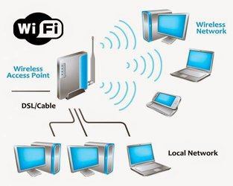

Video of WiFi (3 Mins) <https://www.youtube.com/watch?v=METB1o4UAT8>

<https://www.khanacademy.org/computing/code-org/computers-and-the-internet/internet-works/v/the-internet-wires-cables-and-wifi> (7 mins)

**WiMax :**

Acronym for Worldwide Interoperability for Microwave Access.

Based on Wireless MAN technology.

A wireless technology optimized for the delivery of IP centric services over a wide area.

A scalable wireless platform for constructing alternative and complementary broadband networks.

In practical terms, WiMAX would operate similar to WiFi but at higher speeds, over greater distances and for a greater number of users. WiMAX could potentially erase the suburban and rural blackout areas that currently have no broadband Internet access because phone and cable companies have not yet run the necessary wires to those remote locations.

A WiMAX system consists of two parts

A WiMAX tower, similar in concept to a cell-phone tower - A single WiMAX tower can provide coverage to a very large area -- as big as 3,000 square miles (~8,000 square km).

A WiMAX receiver - The receiver and antenna could be a small box or PCMCIA card, or they could be built into a laptop the way WiFi access is today.

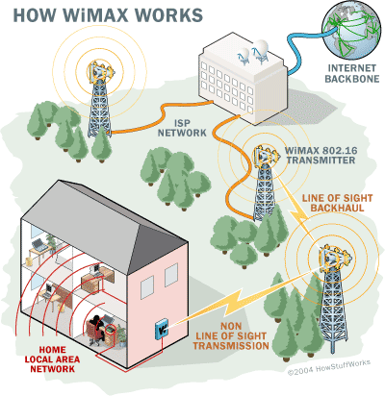

<https://www.youtube.com/watch?v=KQdc5AdJqCg> (WiMax Intro - 1.40 Mins )

<https://www.youtube.com/watch?v=Q93Z5-t5bYY> (WiFi & WiMax - 4.40 Mins)